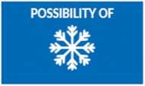

NIGHT

(fiyUNHCR

The UN Refugee Agency

As cold as “ 15°C

**As cold as "**

WINTER IN CANADA

November-March

Wind, snow, ice, blizzard and poor visibility.

WINTER WEATHER RISKS:

In cold, windy, or rainy weather, warm clothes may not be enough to prevent frozen skin and other health risks that could lead to loss of fingers and toes, and in extreme case, DEATH.

TO STAY WARM IN WINTER MAKE SURE TO:

Cover you r neck

Wear warm layers

Wear warm pants

Cover your hands

1 Keep YOUR FEET DRY

Cover your head

Wear a wwter jacket

